PLANNING AND ZONING COMMISSION

Minutes of the Planning and Zoning Meeting of February 21st, 2024

- Attendees: Village of Galena Mayor Jeff Kinnell, P&Z Commission Members Alison Cherubini-Hillyer, Mike Fry. Also present, Levi Koehler Village Zoning Inspector. Residents of Galena present for the meeting were Tom Hopper, Zach Hopper, and Heidi Kinnell.

- Meeting called to order at 7:00pm

ROLL CALL
- Present were P&Z Commission Members Alison Cherubini-Hillyer, Mike Fry, Mayor Jeff Kinnell.

Presentation of the Minutes from January 17th meeting
- Motion to approve – Mike Fry
- 2nd – Alison Cherubini-Hillyer
Roll Call Vote Unanimous

GUEST PARTICIPATION
- None

SUBJECT DISCUSSIONS:

- Vision statement for Common Purpose of the Planning & Zoning Commission – Mayor Kinnell advanced the meeting to discuss the common vision statement for the P&Z Commission. Mike Fry suggested the list as it was expanded upon by the group since the last meeting could be taken to council for their input. Levi Koehler reminded everyone that the list would have to be proposed and accepted during a public hearing before it could be submitted to the Village Council. Everyone agreed that was the next steps in the efforts to solidify a Common Purpose Statement for the Village of Galena Planning and Zoning Commission.

  - The Current Common Purpose Statement reads;

- Planning & Zoning Wish List of Village amenities – progressing the conversation to the “wish list”, Mayor Kinnell stated that this is an extension of the Common Purpose statement. The list had been thru 3 iterations of input being surveyed and ranked with an ultimate outcome of 9 line items.
Planning & Zoning Wish List of Village amenities CONT -

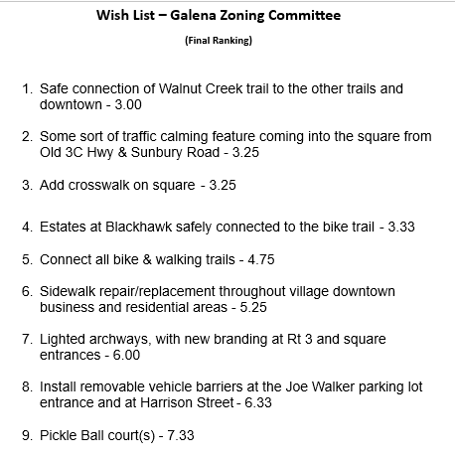

Alison Cherubini-Hillyer suggested that wish list items 1, 4 and 5 were all similar and could be consolidated down to 1 item. All present P&Z Commission members were in agreement with that suggestion. Mayor Jeff suggested consolidating the list further down to possibly 5 items and then review and receive input from the council to receive their “wishes” to add to the list.
Alison also questioned whether items #2 and #3 are under the jurisdiction of ODOT and not the Village. She further questioned placement and the affect that the noise would have on residents close to any location of rumble strips as a traffic calming feature in particular. Levi agreed that they are very noisy and not something you get accustomed to, as he has personally experienced rumble strips close to his residence.

Mayor Jeff shared that he has a meeting the week of 02/26/2024 with the Delaware County Engineer to discuss the options for traffic calming into the Village. The plan is to discuss the viability of the rumble strips. Michael Fry asked if the Mayor could also ask for the addition of crosswalks in the Village Square while meeting with the County Engineer. Back and forth conversation amongst the commission ensued regarding rumble strips.

Alison Cherubini and Mike Fry were both pleased with the seven (7 – when combining 1,4,5) items remaining on the wish list.

Resident Zach Hopper approached to speak to the traffic calming features. Zach inquired whether when the Miller Farm Subdivision goes in off old Sunbury Road would any future rumble strips be placed before or after that developments entrance. Discussions amongst the Commission members and residents ensued. Levi Koehler reminded everyone that beyond the Miller Farm Entrance, Sunbury Road becomes a County Road, therefore under jurisdiction of the County.
Zach requested additional clarification on what #7 meant – to which Mayor Jeff stated that the effort was to have some type of “branding” on all roadways leading into the Village – Identifying that persons are entering Galena. Zach also wanted some backstory regarding #8. Alison Cherubini-Hillyer shared that cars cut through and drive on the bike paths that connect at Joe Walker Road. It has become a hazard to kids/pedestrians. There is fear, amongst residents that live close to this area, that someone will be seriously injured if vehicles continue to use this as a short-cut. Input from both Tom and Zach Hopper agreed that this is unsafe due to some topography that people are unaware of. They shared that with enough weight that path will cave in. Mayor Kinnell suggested #8 on the wish list be advanced to the Village Safety Committee for their review.

In addition Mayor Kinnell shared that there will be a meeting at the Village offices on March 16th with the Delaware County Sheriff in attendance to discuss mounting a neighborhood watch program in the Village of Galena. More Details to come!

ZONING INSPECTORS REPORT: Full copy available upon request to Village
- During Levi’s report out he shared that the Galena Commerce Center is underway and is the first project that has implemented the individual lot grading plan that was passed by Village Zoning last year.
Mayor Jeff asked Levi to explain what that meant. Levi shared that due to problems with developments in the past, the Village chose to add to any future developments the necessity for additional inspections of lot grading throughout the development to ensure that projects are following the approved process and implementation of lot grading.
- Levi also shared that Mayor Kinnell and he met with the Realtor for Arrowhead and felt that it was productive. The owner continues to want to work closely with the Village to come to an agreeable future development of the property.
- Finally Levi also had a meeting with the owners of Berkshire Campground to discuss their plans to update the water/sewer for the property.

ZONING CLERKS REPORT: Nothing to add

NEW/OLD BUSINESS:
- Alison shared that she and Mayor Kinnell as well as Resident and past Mayor Tom Hopper, and Residents Dave Simmons, and Dave O’neil all met with Nathan Bevil of the Ohio History Connections group to further discussions on how to define Galena’s Historical District.

Next meeting is at 7:00 pm Wednesday February 21st, 2024

ADJOURNMENT
Motion to Adjourn at 7:25pm.
- Motion Mike Fry
- 2nd Alison Cherubini-Hillyer
Roll Call Vote - Unanimous

