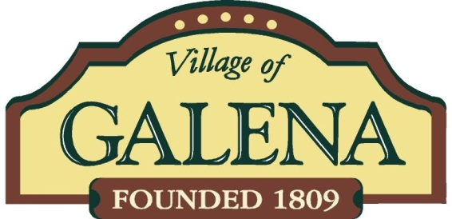

**November 7th Ballot Information**

**Proposed Electric Aggregation – Village of Galena**

The Village of Galena has chosen to add Electric Aggregation to the ballot come November 7th, 2023. Below are some common questions about energy aggregation.

What is Electric Aggregation?

* Aggregation is an option available under Ohio law for consumers to obtain competitive electricity supply. Local governments may aggregate the energy used by their residents and arrange for the purchase of electricity. Purchasing large blocks of energy gives bargaining power and may reduce costs of energy supply.

What does by it mean to Opt-Out Aggregation?

* An Opt-Out Aggregation is a program that results in residents being automatically enrolled in the aggregation unless they individually opt-out of the program. If an individual is currently in their own supply agreement, their current agreement won’t be affected by an aggregation program. Businesses or residential can join the program at no fees. Any business and residence can leave the program with no fees. They can join the program later with no fees. Complete choice program.

What fees will individuals see?

* There will be no fees applied. This electric aggregation is a choice program which gives the people of Galena an option to be a part of or not. If an individual wants to join in later or leave the program later, no fees will be applied. Complete choice!

Will my bill still be AEP?

* Yes! AEP utility oversees providing you with electricity. AEP currently charges you with delivery of electricity and supply of electricity. AEP will continue to provide your electric bill but with a different supply cost. No change in billing will be affected.

Why did the Village of Galena choose to add Electric Aggregation?

* Currently AEP rates are some of the highest in history. Rates have jumped a considerable amount due to energy markets and the national shift into renewable energy. This is giving the people of Galena an option of energy supply at no fees to take advantage of.