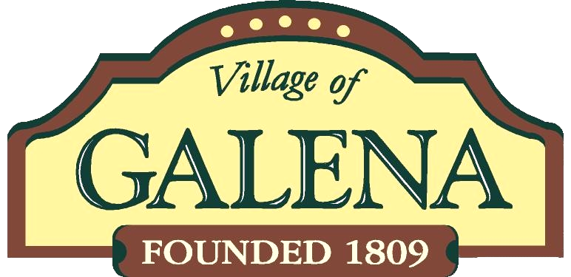 | 2024 Calendar of Events

All meetings are at 7 p.m. in the Village Hall Council Chamber, 109 Harrison St., unless noted otherwise.
Planning & Zoning Commission meetings are on third Wednesdays.
Council meetings are normally on fourth Mondays.
** = Council meeting moved due to a holiday or other scheduling conflict.
Residential trash days are on Wednesdays, however, may shift to a Thursday due to holidays: New Year’s, Memorial, Independence, Labor, Thanksgiving, and Christmas. If the actual holiday is the day-of or a weekday before the Wednesday, then collection day shifts to Thursday. Thursday dates are noted.

Jan. 3 Council Organizational Meeting
6:00 PM
Jan. 15 Martin Luther King Day – Offices Closed
Jan. 17 Planning & Zoning Commission
Jan. 22 Council Meeting
Feb. 21 Planning & Zoning Commission
Feb. 19 President’s Day – Offices Closed
Feb. 26 Council Meeting
Mar. 20 Planning & Zoning Commission
Mar. 25 Council Meeting
Mar. 30 Easter Egg Hunt, 1 PM,
Ruffner Park
April 6 Storytelling Event, 1 PM
Apr. 17 Planning & Zoning Commission
Apr. 22 Council Meeting
May 15 Planning & Zoning Commission
May 20 Council Meeting

May 27 Memorial Day – Offices Closed
Memorial Day Services, 1 PM,
Village Square & Cemetery
June 18 Planning & Zoning Commission
June 19 Juneteenth Observed-Office Closed
June 24 Council Meeting
July 4 Independence Day Observed – Offices Closed
July 17 Planning & Zoning Commission
July 22 Council Meeting
Aug. 21 Planning & Zoning Commission
Aug. 26 Council Meeting
Sept. 2 Labor Day – Offices Closed
Sept. 18 Planning & Zoning Commission
Sept. 23 Council Meeting
Oct. 5 Heritage Day, 11 AM – 2 PM
Oct. 14 Columbus Day – Offices Closed
Oct. 16 Planning & Zoning Commission
Oct TBD Costume Party
Oct. 28 Council Meeting
Oct. 31 Trick or treat, 6-7:30 PM
Nov. 5 General Election Day,
6:30 AM - 7:30 PM
Nov. 11 Veterans Day – Offices Closed
Nov. 20 Planning & Zoning Commission
Nov. 18 Council Meeting
Nov. 28-29 Thanksgiving – Offices Closed
Dec. 1 Christmas @ Journey 6-7 PM
Santa Claus & Tree Lighting
on the Square, 7:30 PM
Dec. 16 Council Meeting
Dec. 18 Planning & Zoning Commission
Dec. 25 Christmas – Offices Closed
Jan. 1, 2025 New Years Day -Offices Closed

Administration/Calendar%20of%20Events/Calendar%20of%20Events/Calendar%20of%20Events%202021.docx

